Creating a Monitoring Service

**Creating a Web Server Monitoring Service**

Before we start the demonstration of monitoring Apache HTTP service on remote client make sure that you have gone through the Nagios installation process. This demonstration documentation is the continuation of the NAGIOS INSTALLATION.

**Commands with green font represents master, white font terminal represents slave.**

**Step 1:** Install apache web server on the client machine.

$ sudo apt update

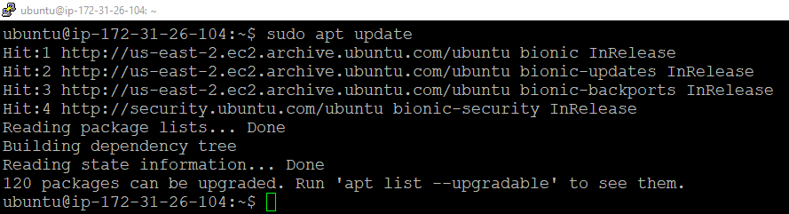

**Step 2:** Run the following two commands after that.

$ sudo apt install apache2

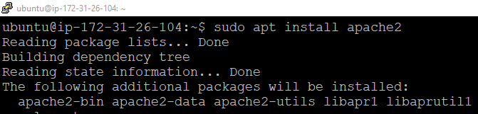

**Step 3:** Now, check if the web server is up and running.

$ sudo systemctl status apache2

You can add passwords and Enter the user information as shown below.

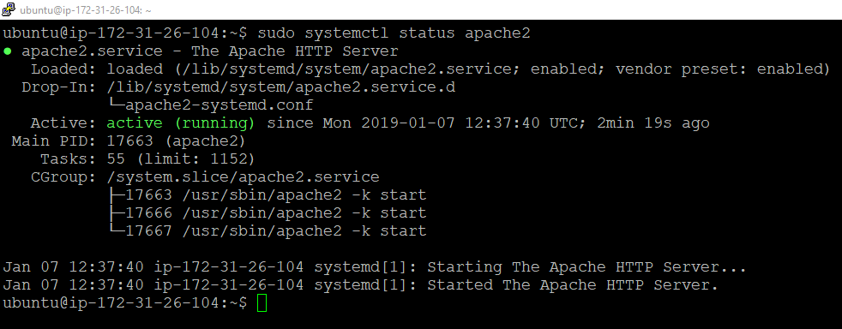

Looks fine!

**Step 4:** Run the following commands to complete the user adding process.

$ sudo systemctl start apache2

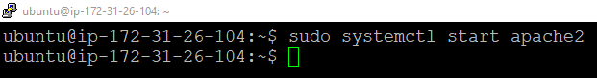

**Step 5:** Open browser and enter the following URL.

$ http://SLAVE_IP/

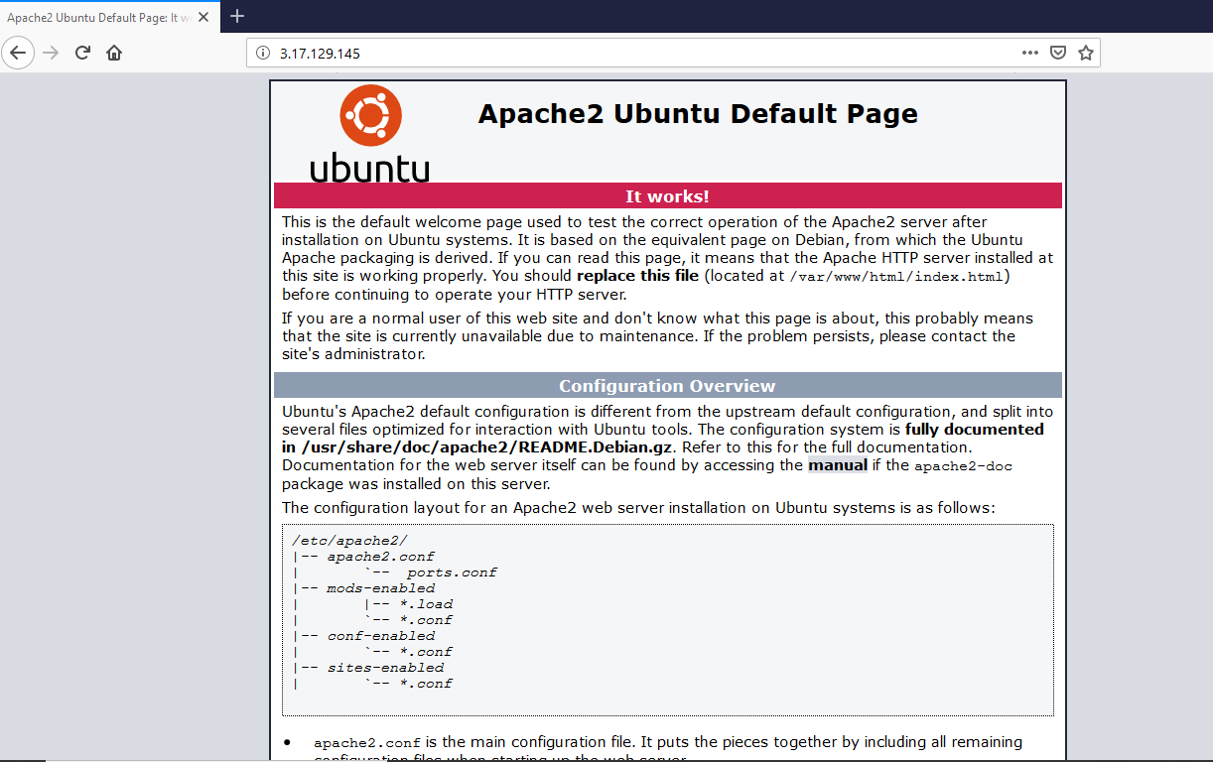

**Add the service definitions in the master machine**

**Step 6:** Add the service definitions in the host configuration file.

$ sudo nano /usr/local/nagios/etc/servers/MyHost01.cfg

**

define service {

use generic-service ; Inherit default values from a template

host_name <add_host_name>

service_description HTTP

check_command check_http

}

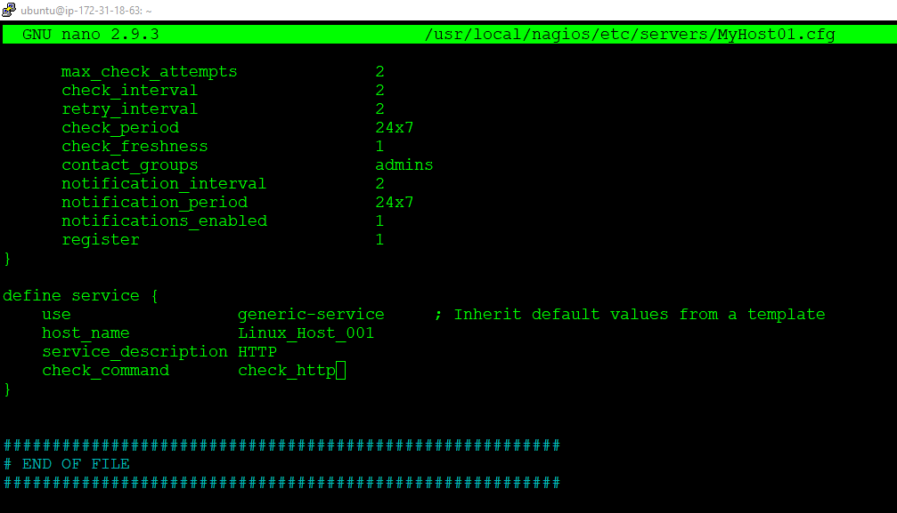

**Step 7:** Check the nagios configuration file status before starting nagios again.

$ sudo /usr/local/nagios/bin/nagios -v /usr/local/nagios/etc/nagios.cfg

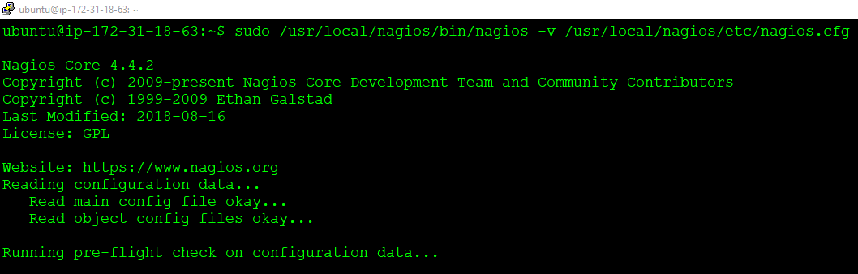

**Step 8:** Now with the given command make the required configurations.

$ sudo service nagios restart

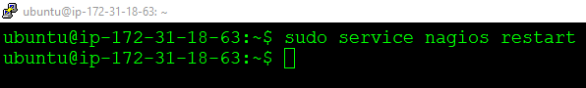

**Step 9:** Now go to browser, enter <http://masterIP/nagios/> .There click on **Services**. You can see a new **HTTP service** added with our last **PING service** in the **Linux_Host_001** client.

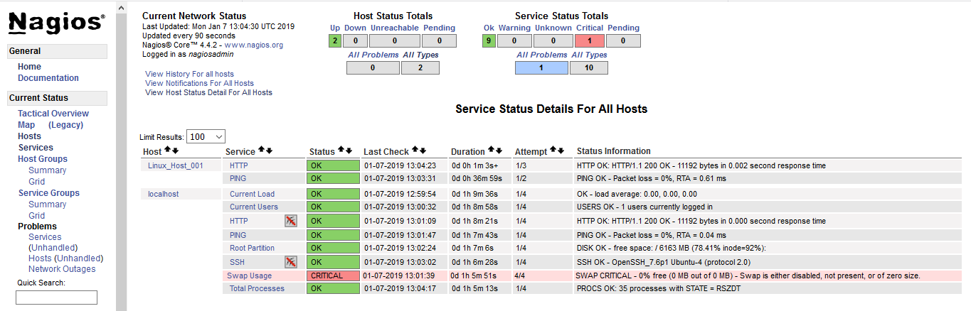

**Congratulations!** You have successfully added a Web Server Monitoring Service in your Client machine.